- Next-gen sequencing
  - Previous generation sequencing: slow, tedious -> less data
  - Next-generation sequencing:
    - Increasingly fast, automated, cheaper
    - High volumes of data per sample
    - New functions (Ex: ChIP-seq) invented all the time
      - There will always be new sequencing technology
      - Basic principles of how to deal with this type of data
- Different techniques for both
  - 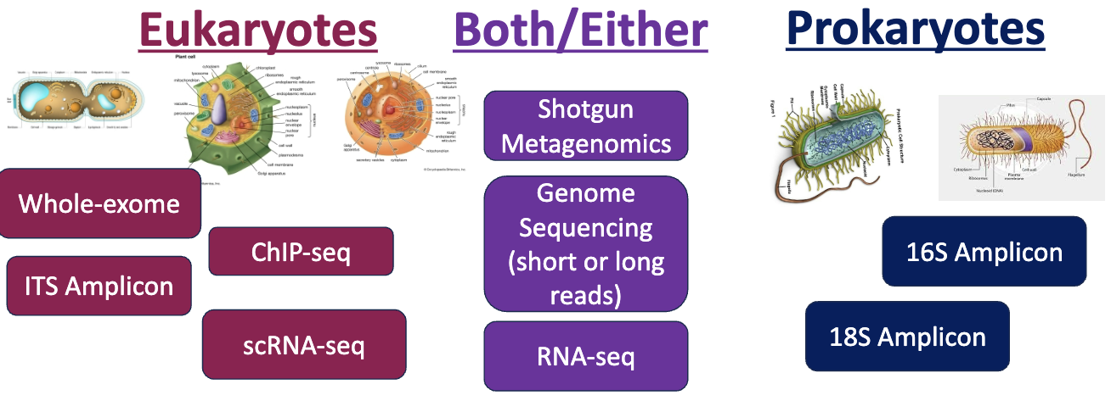
- Common Issues w/ NGS seq data
  - Sparsity – lots of 0s
  - Compositionality
  - So many features
- 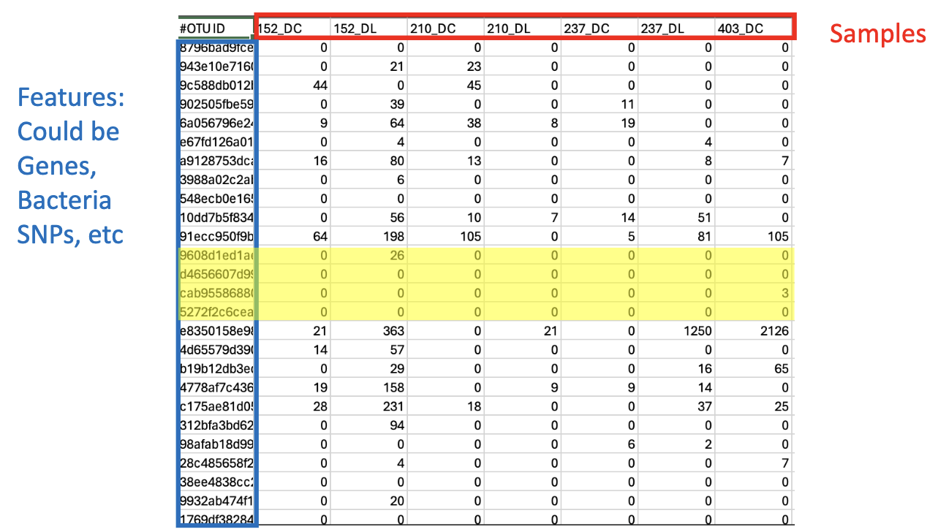
- Zero Handling: Too many Zeros
  - NGS datasets are typically FULL of Zeros
  - Why is this a problem?
    - Adds more features (slows down code)
    - Features with lots of zeroes can’t differentiate conditions
    - Less confidence in low-abundance features
  - What to do?
    - Remove features with many zeroes
      - What’s the cutoff?
    - Replace zeroes
- Compositional Nature of Sequencing Data
  - Sequence data are compositional (add up to a fixed number)
    - All features are a part of that number
  - All the common normalizations methods do not account for this fact (e.g. rarefaction, TMP)
  - Serious problems with I.I.D. (Independence of data points)
  - Ex:
    - Sequencing Data: Relative abundances are proportions of various counts. 5 different bacteria abundances [0.2,0.3,0.25,0.20,0.05]
  - The problem
    - Sequence data is a subsample of sequences in a sample
    - Sequencing depth is arbitrary to biomass
    - Counts do not correspond to absolute abundances
    - All sequencing data, not just microbiome data!
    - Sequence data are proportional
    - Measured in “relative abundance”
    - If count of one sequence increases, the others MUST decrease relatively speaking
    - Creates feature inter-dependence:
      - statistical issues, spurious correlations
      - 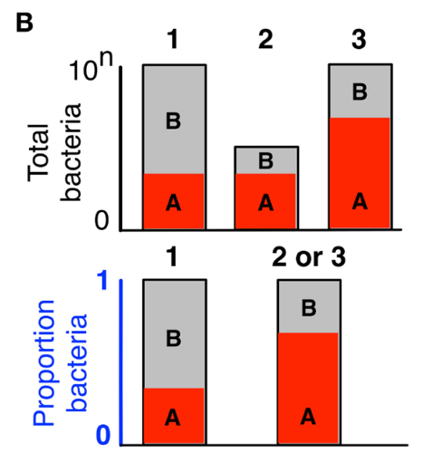
  - Solutions to Compositionality
    - Solution 1: Determine absolute abundances
      - Normalize NGS sequencing counts to quantitative PCR counts
      - 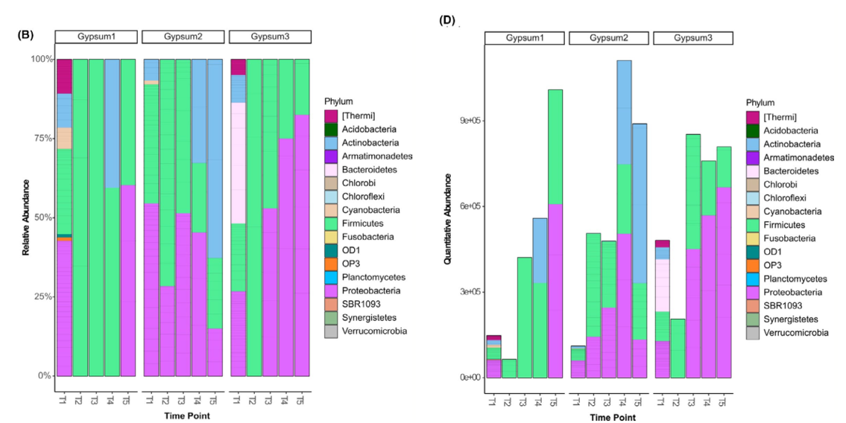
    - Solution 2: Data Transformation
      - Compositional (relative space) -> real (Euclidean) space
        - 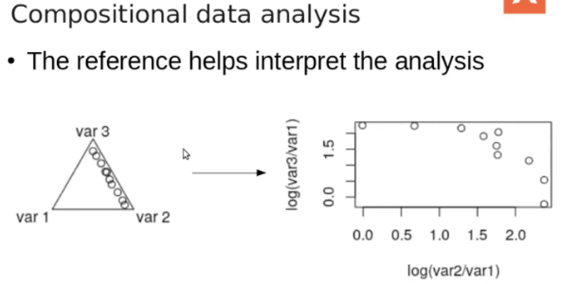
      - Log-ratio transformations: log ratio of counts to some aspect of each sample
        - alr: log ratio of counts relative to a feature in each sample
        - Ilr: log ratio of counts relative to data components
        - clr – centered log-ratio Log ratio of counts relative to the geometric mean of the sample
          - Allows combination of data at very different scales (e.g., metagenomics and metabolomics)
          - Allows us of Euclidean (real) Distances – USE NMDS or PCA not PCoA
          - The transformed data can be used in correlation analyses, Machine learning,
            - $clr\left(x_{j}\right)=\left[\ln{\frac{x_{1j}}{g\left(x_{j}\right)},……. .. , }\frac{x_{Dj}}{g\left(x_{j}\right)}\right]$
          - Combining datasets
            - Sometimes they can be on massively different scales and distributions
            - clr transformation puts them on the same scale
          - Ex:
            - 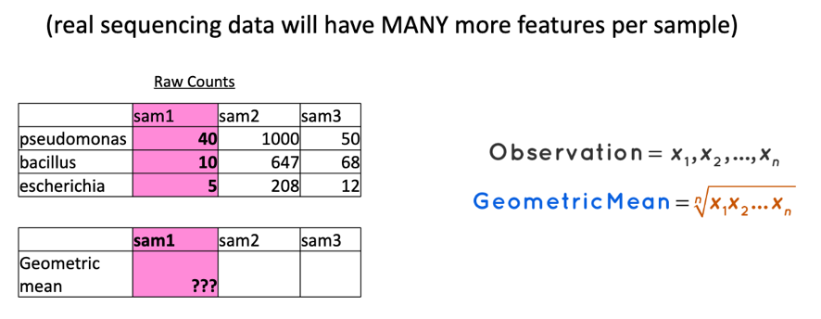
            - 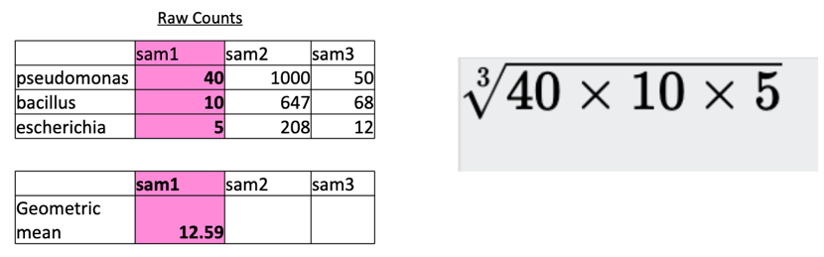
            - 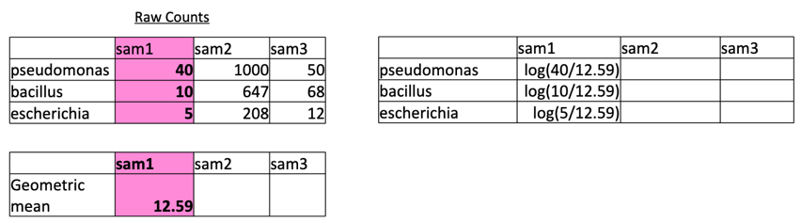
            - 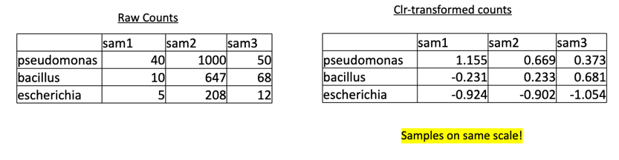
- Zero Handling
  - Log-ratio methods cannot handle zeros (you cannot take the log of 0)
  - Replace zeros:
    - Replace them with a VERY small number (like 0.001)
    - Use a pseudo-count based on some distribution (zCompositions)
  - New method: “robust” clr
    - Do clr ignoring the features with zeroes
    - Put zeroes back in
- Which features are different between conditions?
  - Why can’t we just do a T-test or ANOVA on each feature
  - Multiple comparison problem
    - 100 features -> 5 of them will have p < 0.05 just by chance
    - If we have targeted questions for a few features, plain stats tests (on clr-transformed data) is fine
      - E.g. is Bacteroides more abundant in group A vs group B?
    - Often, we don’t have targeted questions
    - Many differential abundance methods

